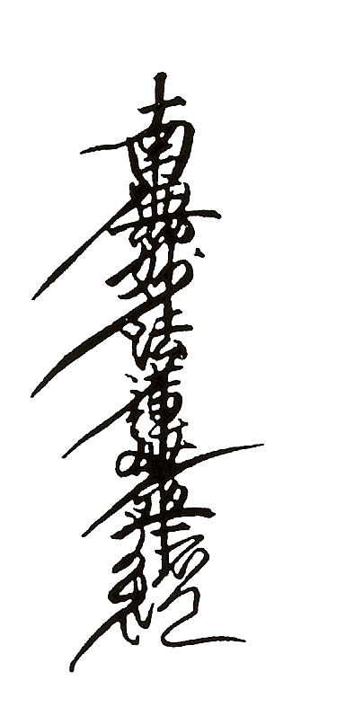
Na-Mu Myo Ho Ren Ge Kyo

The Buddha taught 2 most important things
which we still very much need to follow today:
the practice of giving, to help other people and nurture life,
and the precept of non-killing, no matter how badly we may be provoked.
If we do not remember how special and precious life is,
and what powers we have, to overcome untruth by truth, hatred by love, and violence by self-sacrifice- then life becomes cheap.
Then, we have no other response to violence then violence,
creating further violence and suffering.
All of us are special, our life a precious gift:
let us use our life to do what we can, together
to bring light and relieve suffering, paying respect to the Buddha
inside us all.

(Based on ‘Kanjin Honzon; 1975, Most Ven. N.Fujii ,Founder of Nipponzan Myohoji)

Nipponzan Myohoji cordially invites you and your friends to attend
The 42nd Anniversary Celebration of the Milton Keynes Peace Pagoda on
Sunday, 19th June 2022

12 noon - Annual ceremony by Nipponzan Myohoji,
Including chanting from various Buddhist traditions

1.00 pm - Multi-faith Prayers for Peace

1.30 pm - Speeches and Messages of Peace

2.00 pm - Lunch Interval.

2.15 pm - Music, Dance & Cultural performances

3.45 pm - Conclusion

Everyone is welcome to spontaneously offer prayers, chanting, candles, incense, flowers, etc.

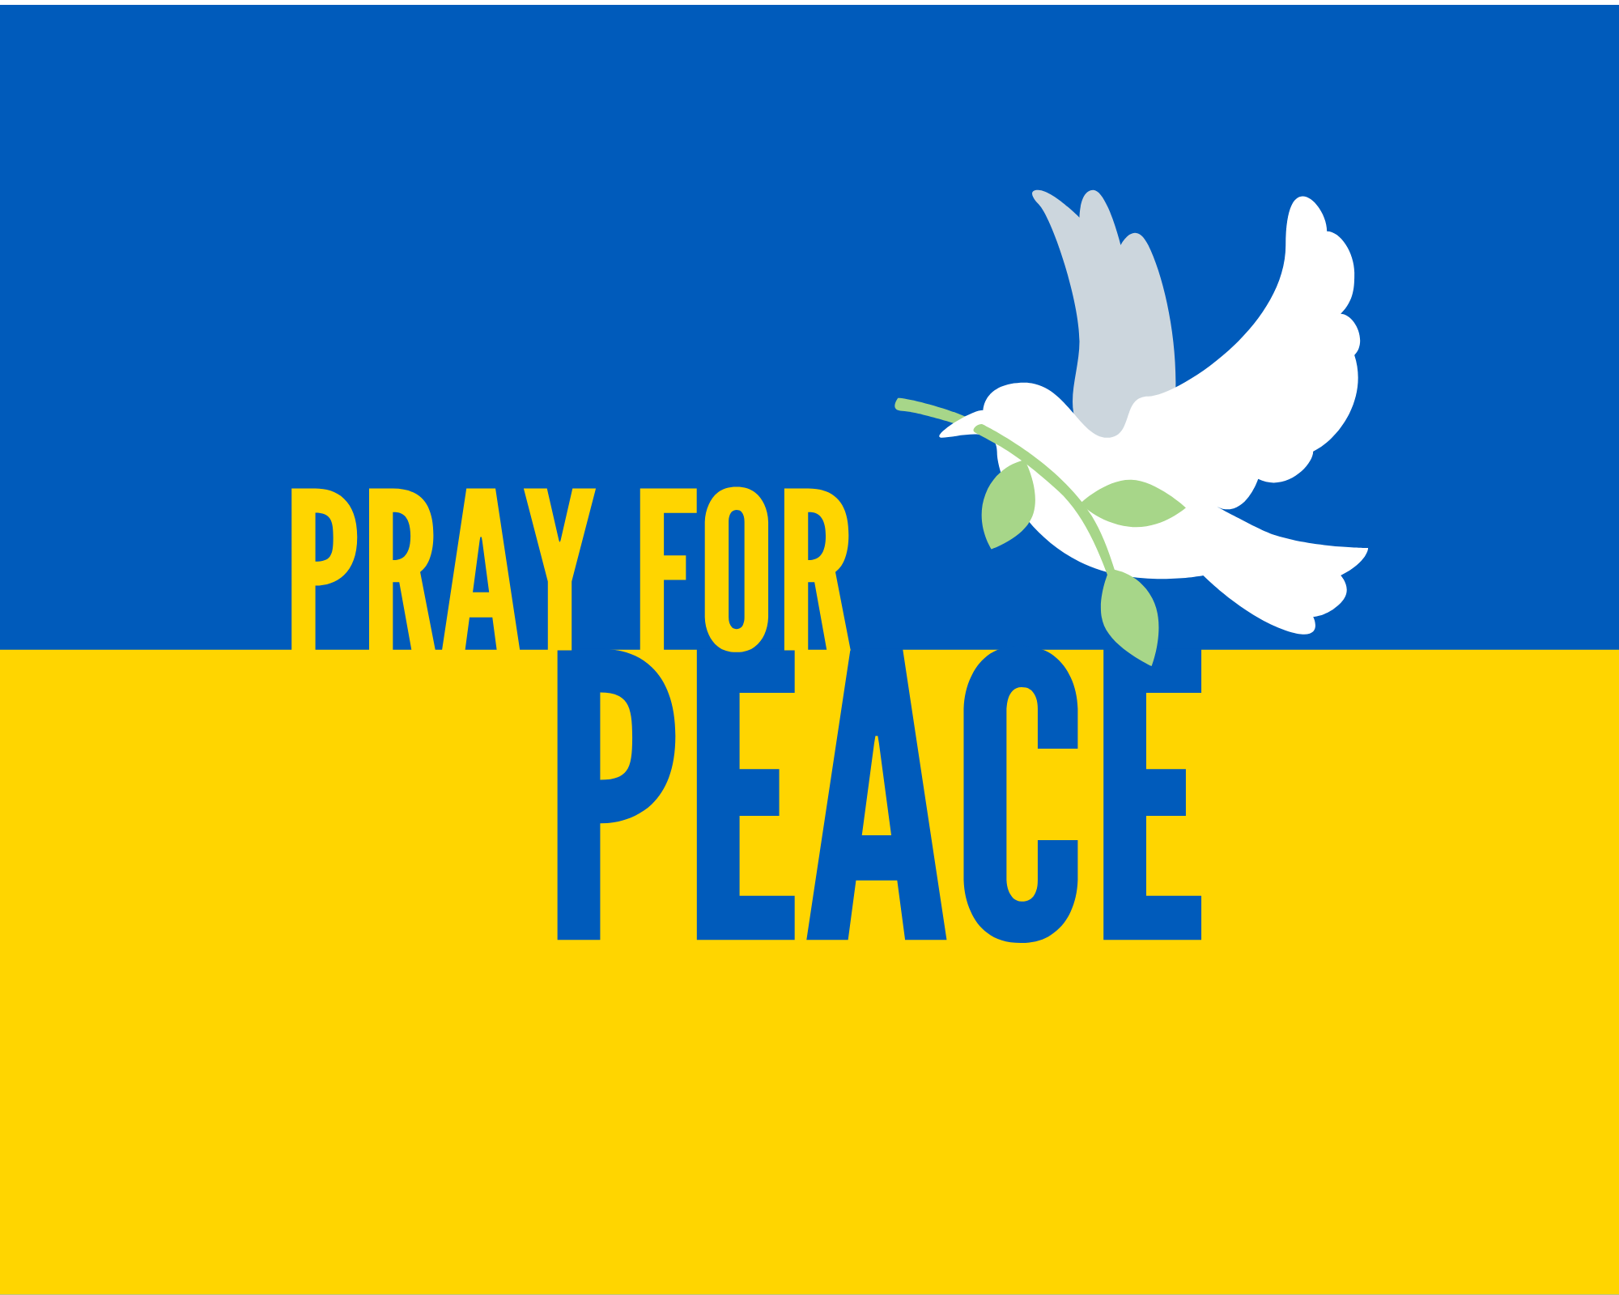
Life is the greatest treasure

